**Chapter 7 Web Project 3** 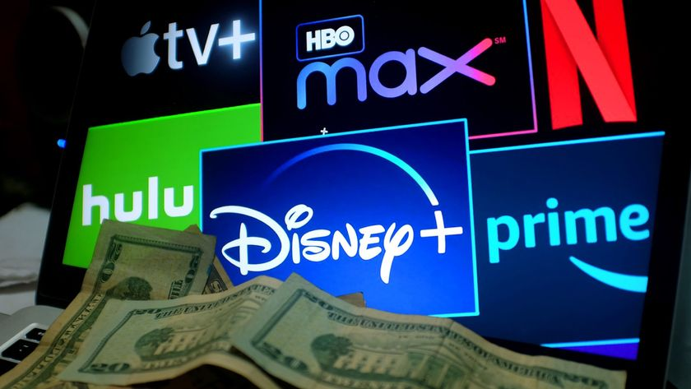

**Watch TV without Buying Cable**

**Student: Leslie N. Guevara Amaya**

**Course: CMSC110**

**Professor: Jason Lee**

**Due Date: April 2nd, 2025**

Watch TV without Buying Cable

With cable prices getting more expensive, a lot of people are looking for other ways to watch TV without paying for a traditional subscription. Streaming services have become one of the most popular options since they offer a wide selection of shows and movies, often at a lower cost. This paper looks at different streaming services, their costs, how easy they are to set up, and whether they’re a good alternative to cable.

### **Cable Alternatives**

There are plenty of streaming services available, each with different pricing and features. Some of the most popular ones include:

* **Netflix** – A go-to for on-demand shows and movies, plus original content. Plans start at $6.99 per month (Fischer).
* **Hulu** – Offers both on-demand shows and live TV. Prices start at $7.99 per month, while Hulu + Live TV costs $76.99 per month (Lynch).
* **Disney+** – Perfect for Disney, Marvel, and Star Wars fans. Starts at $7.99 per month (McCann).
* **Amazon Prime Video** – Comes with an Amazon Prime membership ($14.99/month or $139/year), with both included content and rentals (Snider).
* **YouTube TV** – A live TV alternative with major channels. Costs $72.99 per month (Peterson).

### **Free Streaming Options**

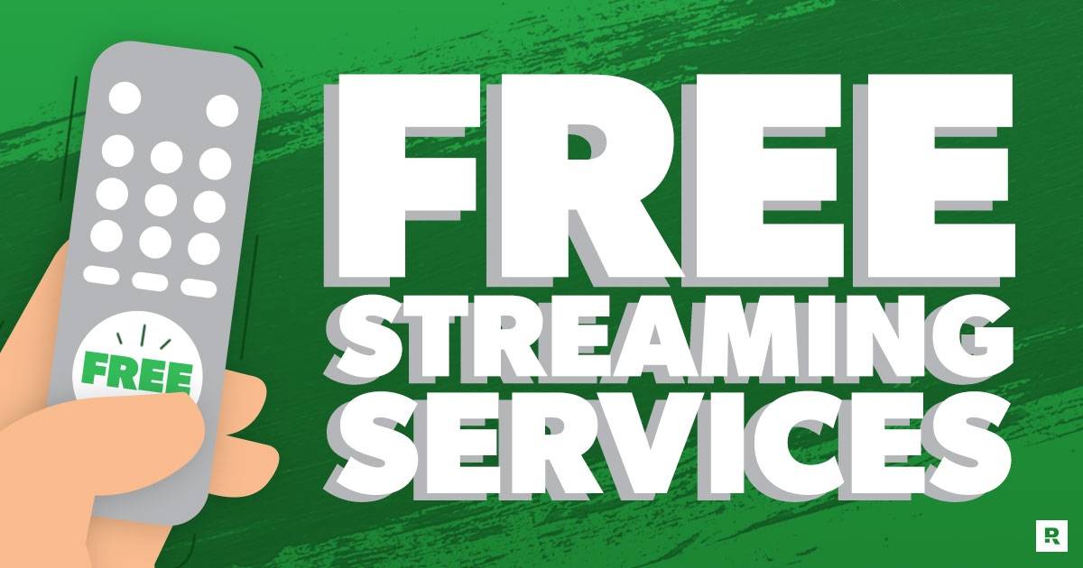

If paying for a subscription isn’t an option, there are also free streaming services that make money through ads:

* **Pluto TV** – Offers a variety of live TV channels and on-demand content for free.
* **Tubi** – A solid selection of movies and shows, no subscription needed.
* **Crackle** – Free movies and original content, but with ads.

### **Setup & Ease of Use**

Streaming services are pretty easy to set up. You just need a device like a smart TV, streaming stick (Roku, Amazon Fire Stick, etc.), gaming console, or even just a phone or laptop. After downloading the app, you create an account, choose a plan, and start watching. Compared to cable, streaming is more flexible and doesn’t require complicated installations or long-term contracts.

### **My Experience & Thoughts**

I already use Netflix, and I like how I can watch what I want whenever I have time. After researching, I might try amazon prime video since it has lots of different varieties of shows and movies as well as a fair price.

### **Conclusion**

Cutting cable has become a lot easier with the rise of streaming services. There are so many options available that fit different budgets, from paid services with tons of content to free platforms that still provide quality entertainment. The setup is simple, and streaming gives users more flexibility than cable. After researching different services, it’s clear that streaming is the better option for anyone looking to save money and still enjoy their favorite shows and movies.

### **Works Cited**

Fischer, Tyler. "Netflix Subscription Plans and Prices Explained (2024)." *Tom’s Guide*, 5 Mar. 2024, www.tomsguide.com/netflix-subscription-plans.

Lynch, Jason. "Hulu’s Pricing and Plans in 2024: Is It Worth It?" *CNET*, 10 Mar. 2024, www.cnet.com/hulu-price-plans-2024.

McCann, John. "Disney Plus vs. Netflix: Which Should You Get?" *Digital Trends*, 7 Mar. 2024, www.digitaltrends.com/disney-plus-vs-netflix.

Snider, Mike. "Amazon Prime Video: What You Need to Know Before Subscribing." *USA Today*, 15 Mar. 2024, www.usatoday.com/amazon-prime-video-guide.

Peterson, Tim. "YouTube TV: Price, Channels, and Features Compared to Cable." *Wall Street Journal*, 12 Mar. 2024, www.wsj.com/youtube-tv-vs-cable.